GREENHILL PRIMARY SCHOOL BUWAATE
P.5 MATHEMATICS REVISION WORK SET II
TERM III, 2019
Name: _______________________________ Stream: _________
SECTION A:

- Find the missing numbers in the sequence;
100 , 98 , 96 , ____ , 92 , ____

- Find the next two equivalent fractions of .

- What integer is represented on the number line below?
⁻7 ⁻6 ⁻5 ⁻4 ⁻3 ⁻2 ⁻1 0 1 2 3 4 5 6
x

x = ______________

- Write down all the factors of 18.

- Shade  of

- Starting from the marked point, show ⁻8 on the numberline below.

⁻5 ⁻4 ⁻3 ⁻2 ⁻1 0 1 2 3 4 5 6

- Write down the multiples of 8 less than 50.

- Use > , < or = to complete.
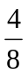 __________ 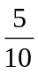

- Find the square of 16.

- Use < , > or = to compare
⁻6 ________⁺2

SECTION B
- Write down the first six;

- whole numbers

- odd numbers

- counting numbers

- even numbers

- prime numbers

- Three teachers used an hour to address the pupils during the class meeting. Tr. Dan used of the time, Tr. Joan used of the time and Tr. Visensio used the remaining time.
- What fraction of the time did Tr. Dan and Tr. Joan use altogether?

- What fraction did Tr. Visensio use?

- How many more minutes did Tr. Visensio use than Tr. Joan?

- Study the numberline below and use it to answer the questions that follow
⁻7 ⁻6 ⁻5 ⁻4 ⁻3 ⁻2 ⁻1 0 1 2 3 4 5 6
x
r
q
p

Write the integer represented by;
- x = ______________
- p = ______________
- r = ______________
- q = ______________

b) Find the inverse of ⁺9

- Using a pencil, a ruler and a pair of compasses only, construct a regular hexagon using a circle of radius 4cm.

GREENHILL PRIMARY SCHOOL BUWAATE
P.5 MATHEMATICS REVISION WORK SET III
TERM III, 2019
Name: _______________________________ Stream: _________
SECTION A:

- Draw a square and show the lines of folding symmetry.


- If represents 16 balls, how many balls are represented by
?

- Draw an angle of 52⁰ in the space below.


- If represents 6 stools. Draw pictures to represent 42 stools.

- How many lines of folding symmetry has a rectangle?

- Find the smaller angle between North and South East?

- David has 8 big counter books and 9 small exercise books. Draw tallies to represent the total number of books David has?

- Using a pencil, a ruler and a pair of compasses only, construct an angle of 60⁰

- What is the larger angle between East and South West?

- Draw a line perpendicular to line AB

A
B

SECTION B
- Find the values of the missing angles.
48⁰
2p

60⁰
k
2k
x
40⁰
(c)

(b)

- The data below shows the ages of different children collected at a hospital in a week. Use it to answer the questions that follow.
4 3 9 3 4 2
8 4 2 6 7 2
2 8 4 5 3 9
7 6 8 7 4 9
- Fill in the table below
Age | Tally | Frequency
2 – 3 years
4 – 5 years
6 – 7 years
8 -9 years

- How many children were recorded?

- a) Construct a square PQRS where PQ=QR=RS=PS = 4.5cm

b) Measure diagonal PR ………………………………

- a) Convert 24 weeks to days

b) Workout the following

i) Weeks days ii)
3 6
+ 2 5

Weeks days
5 0
- 2 4

GREENHILL PRIMARY SCHOOL BUWAATE
P.5 MATHEMATICS REVISION WORK EVALUATION TEST. 1
TERM III, 2019
Name: _______________________________ Stream: _________
SECTION A:

- Multiply: 28 x 6

- Name the shaded region.
P
Q

- Expand 4629 using values.

- Find the sum of the missing numbers in the sequence below.
12 , 20 , 28 , 36 , _____ , _____

- Fill in the box with the correct value
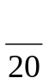 = 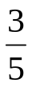

- What is the additive inverse
of ⁻10.

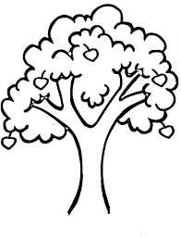
- Given that represents 3 trees. Draw pictures to represent 15 trees.

- Name the figure below.

- How many days are in 5 weeks 5days?

- Musa had shs. 2450 and he was added shs. 7850. How much money does he have altogether?

SECTION B
- Study the figure below and answer the questions that follow.
6m
4m
A
B
C
D
p
k

- Find the value of:

- p

- k

- Find the total distance an insect will cover if it moves around the above figure 5 times.

- What is the area of the above figure?

- Given that p = m = 6 and k = 5. Find the value of;

- p + k + m

- pk – 2m

- Juma bought the following items from the shop
2 kg of meat at shs. 9000 a kg
1 bar of soap at shs. 3200
1 kg of sugar st shs. 3500
4 litres milk at shs. 4000

- How much did he pay?

- If he had a twenty thousand shilling note and a ten thousand shilling note, what was his change?

- a) How many minutes are in 6 hours?

- Workout the following.

- Hours minutes
3 4 5
+ 2 2 5

- Hours minutes
- 2 0
- 3 4 5

- A p.5 pupil scored the following marks in a test marked out of 50.
49 , 48 , 50 , 42 , 31

- Find the range of her marks

- What was her modal mark?

- Find her median mark.

- Calculate his average mark.

- Using a pencil a ruler and a pair of compasses only, construct a rectangle KLMN where KL = MN = 6cm and LM = KN = 4cm

b) Find its perimeter.

GREENHILL PRIMARY SCHOOL BUWAATE
P.5 MATHEMATICS REVISION WORK SET IV
TERM III, 2019
Name: _______________________________ Stream: _________

- Write the number shown on the abacus in words
O
T
H
TH
O
O
O
O
O
O
O
O

- Set P = {1, 2, 3, 4 , 5 } and
Set Q = { 0, 2, 4, 6, 8}. What is the relationship between set P and set Q?

- Divide
1 5 1 5
5

- What is the sum of 247 and 3629?

- Set K = {first six letters of the alphabet} and set M = {all vowel letters}.
Find M n K

- What number has been expanded to give (3x1000) + (4 x 10) + (6 x 100) + (9 x 1)

- Write 48 in Roman numerals

- Take away 867 from 2000

- Given that Set B = { p, o, c, k} and
Set A ={p, o, k, e}. Find B ∪ A.

- Round off 325 to the nearest tens.

SECION B

- (a) what is the place value of 3 in 324_{five}

(b) Add: 243_{five} + 42_{five}

(c) Convert 143_{five} to base ten

- Given the number 48295
- Write the above number in words

- Expand the above number using;
- Place values

- Values

- Powers of 10

- Find the sum of the values of 4 and 2 in the above number.

- Study the venn diagram below
P
Q
7 8
1 2 3
0 6 5 4

- List down the elements of

- P

- Q

- P n Q

- Q - P

- Find n(P u Q)

- (a) Using a ruler, a pencil and a pair of compasses only, construct a triangle PQR where PR = 7cm and QR = PR = 5cm

(b) Measure angle PQR

GREENHILL PRIMARY SCHOOL BUWAATE
P.5 MATHEMATICS REVISION WORK SET V
TERM III, 2019
Name: _______________________________ Stream: _________

- Find the sum of and .

- Find the GCF of 8 and 12

- Find the next number in the sequence; 2, 3, 5, 7, _____

- Write to a mixed fraction.

- Arrange ⁻4, ⁺4, ⁺3, 0, ⁻2 starting with the smallest.

- Find the LCM of 4 and 8

- Arrange 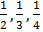and starting with the biggest.

- Add 3 + 4 using a number line.

- Subtract from

- Find the square root of 36

SECTION B
- (a) Write down the prime factors of 24 and 18 in subscript form.

- Show the above prime factors in the venn diagram below.
F₂₄
F₁₈

- (a) Given the number 36. 75
- Write the above number in words

- Find the place value 5 in the above number.

- What is the value of 7 in the above number?

(b) Workout the following.
- 48. 26 + 3.7

- 34.2 – 3.61

- Study the numberline below
X
⁻5 ⁻4 ⁻3 ⁻2 ⁻1 0 ⁺1 ⁺2 ⁺3 ⁺4 ⁺5 ⁺6 ⁺ 7 ⁺ 8
P
Y

- Find the value of;
- X =____________

- Y =_________

- P=______________

- Write the mathematical statement shown above.

- (a) Using the sketch given below. Construct an accurate triangle.
M
K
D
5 cm
7 cm

- Measure line MD

- Measure angle KDA

GREENHILL PRIMARY SCHOOL BUWAATE
P.5 MATHEMATICS REVISION WORK SET VI
TERM III, 2019
Name: ____________________________ Stream: _________

- A mathematics lesson began at 8:40am and ended at 11:00am. How long was the lesson?

- How many lines of folding symmetry has the figure below?

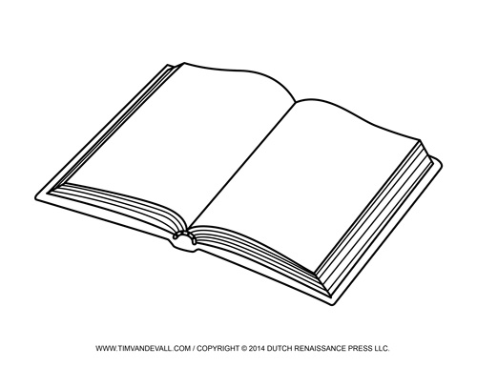
- Two different classes were given the following number of books.
CLASSNUMBER OF BOOKSP.5P.6

If represents 30 books, how many more books where given to P.5 than P.6?

- How many degrees are in a revolution?

- Find the average of 30, 90, 25 and 55.

- Name the figure below.

- Measure the angle below.

- Amos dug for 4 hours. For how long did he dig in minutes?

- Dennis turned from North to South East clockwise, through which angle did he turn?

- Find the distance covered by a car moving at a speed of 38km/hr for 4 hours.

SECTION B
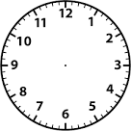
- (a) Write the morning time shown on the clock face below.

- A forty-minute lesson started at 11:30pm. When did it end?

- A motorist covered a distance of 300km in 5 hours. At what speed was he traveling

- The graph below shows the number of text books given out to different schools.
Scale: Represents 12 books.
SCHOOLNUMBER OF BOOKSSeeta p/sCity parents p/sGreenhill p/sHillside p/s

- Which school got the highest number of books?

- How many more books did Seeta Primary school get than Hillside Primary school?

- How many dozens of books did City parents get?

- How many books did the four schools get altogether?

- The bus leaves Kampala for Jinja Via Mukono as shown below.
Town | Arrival | Departure
Kampala |  | 8:00am
Mukono | 9:30 am | 10:00am
Jinja | 12:00 noon

- At what time did the bus;
- Leave kampala?_____________
- Arrive at Jinja?______________

- How long did the bus stay in Mukono?

- Find the total time the bus spends on the whole journey.

- If the bus travelled at an average speed of 40km/hr. how far is Jinja from Kampala?

- Construct a rectangle BDKM of length 6cm and width 4.5cm.

GREENHILL PRIMARY SCHOOL BUWAATE
P.5 MATHEMATICS REVISION WORK EVALUATION TEST. 2
TERM III, 2019
Name: _______________________________ Stream: _________

- Subtract from 3

- Find the common divisor of 9 and 6.

- Add ⁻2 + 6 using a numberline.

- How many litre bottles can be got from a 15 litre jerycan?

- Arrange 1.4, 3.6, 2.7, 0.8 starting with the biggest.

- Find the next number in the sequence; 1, 3, 5, 7, ____, ______

- Write as a decimal fraction.

- Workout ⁻8 + ⁺3 without a numberline.

- What is the inverse of 100?

- Find the product of and .

SECTION B
- Set A ={p, o, i, n, t, e, d} and
Set K ={p, e, n, c, i, l}
- Show the above sets on the venn diagram below.
K
A

- Find the elements of
- A – K

- n(K ∩ A)

- Study the abacus below.
o
o
o
o
o
o
o
o
o
o
o
o
o
o
o
o
o

- Complete the above abacus.
- Round off the number shown on the abacus to the nearest;
- tens

- thousands

- hundreds

- The table below shows the number of pupils who went to the trip using different buses.
Buses | Number of pupils |  | Number of teachers
Buses | Boys | Girls | Females | Males
B | 19 | 22 | 2 | 3
C | 24 | 31 | 1 | 4
D | 18 | 32 | 6 | 2

- How many pupils were in bus C?

- How many girls went for the tour altogether?

- How many more girls than boys went for the tour?

- If every teacher was given airtime worth shs. 20,000. How much money was given to the teachers?

- If all boys in bus D shared 108 sweets, how many sweets did each boy get?

- In a school of 400 pupils, are boys and the rest are girls.
- Find the number of;
- Boys

- Girls

- If of the boys have uniforms, how many boys have no uniforms?

- Study the numberline below and use it to answer the questions that follow.
M
K
⁻5 ⁻4 ⁻3 ⁻2 ⁻1 0 ⁺1 ⁺2 ⁺3 ⁺4 ⁺5 ⁺6 ⁺ 7 ⁺ 8
N

- Find the value of;

(i) K =__________ (ii) N=___________ (iii) M=____________

- Write the mathematical statement shown above.

- (a) Construct a polygon PMK where PM=5.5cm. MK=KP=4cm.

(b) Measure angle KPM

GREENHILL PRIMARY SCHOOL BUWAATE
P.5 MATHEMATICS REVISION WORK SET VII
TERM III, 2019
Name: ____________________________ Stream: _________

- A boy bought a book at shs. 9000 and sold it at shs. 10,500. How much did he gain?

- Add: Km M
3 4 7 6 0
+ 1 2 9 8 0

- Find the value of k if 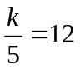

- David bought a goat at shs. 250,000 and sold it making a profit of shs. 50,000. Find the selling price of the goat.

- How many packets of type A can be got from sack B?
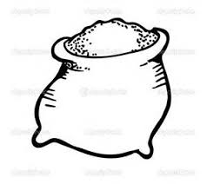
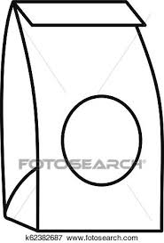
6kg
500g
B
A

- I think of a number, double it and add 13, the result is 33. What is the number?

- Study the figure below and find its perimeter
8m
3m
4m
10m

- Add: Litres ml
3 4 8 7
+ 2 6 9 3

- Find the volume of the figure below.
8cm

- A trader bought a shirt and sold it at shs. 8500 making a profit of shs. 1,500. How much did he buy the shirt?

SECTION B
- Given that p = 6, q = 9 and r=4. Find the value of:
- 2p + q

- P² ÷ r

- Pqr

- (a) Convert 8kg to grams

(b) Add: Kg g
4 9 7 0
+ 2 2 4 0

(b) Subtract: Kg g
3 5 0
+ 2 1 2 0

- Rihana bought the following items from the shop:
Three kilograms of onions at shs. 2000 per kg
One and ahalf kilograms of peas at shs. 3000 per kg
Two kilograms of rice at shs. 8000
(a) How much money did she spend on all the items?

(b) If she was given change of shs. 1,500. How much money did she have at first?

- (a) Construct a triangle ABC where
AB = 5cm and BC= AC = 4cm.

(b) Measure angle BAC

GREENHILL PRIMARY SCHOOL BUWAATE
P.5 MATHEMATICS REVISION WORK SET VIII
TERM III, 2019
Name: ____________________________ Stream: _________

- Share 144 sweets equally among 6 boys. How many sweets did each boy get?

- Name the shaded set region.
K
P

- Write 34 in Roman numerals

- Set P = {even numbers less than 12}. Find n(P)

- A tray of eggs holds 30 eggs. How many eggs can 6 trays hold?

- Set M = {man}. List down the subsets of set M.

- Subtract: 22_{five} from 413_{five}

- Divide 156 by 12 using long division.

- Shade P – Q on the venn diagram below
Q
P

- Set K = {a, b, c , d, e} and
Set Q = {a, e, i, o u}. List down the elements of set K which are not in set Q.

SECTION B
- (a) Write 213_{five} in words.

(b) Write the place value of 1 in 213_{five}

(c) Convert 21_{ten} to base five

(d) Workout: 214_{five} + 44_{five}

- David is X years old and John is 5 years older than David. If their total age is 25 years,
- How old is each?

- How old will David be after 10 years?

- In a class, 15 pupils like beans (B), 20 like posho (P) and 6 like both.
- Complete the venn diagram below
n(B) =15
n(P) =20

- How many pupils like;
- Beans only

- Only One type of food.

- Construct a four sided polygon DECK where DE=EC=CK=DK=5.5cm

b) Find its perimeter.

GREENHILL PRIMARY SCHOOL BUWAATE
P.5 MATHEMATICS REVISION WORK SET IX
TERM III, 2019
Name: ____________________________ Stream: _________

- What is the first day of the week?

- Find the smaller angle between south and west.

- John bought 4 rubbers at shs. 2400. How much will James pay for 6 similar rubbers at the same rate?

- Engoru was facing West and turned anticlockwise to face south East. Through what angle did he turn?

- A cyclist travelled a distance of 180km at an average speed of 60km/hr. For how long did he travel?

- Tom spent 480 months in London. For how many years was he in London?

- Construct a right angle in the space below.

- Measure angle PKR
X
K
P
R

- What is the larger angle between East and South West?

- Convert 56 days to weeks.

SECTION B
- (a) Nambuya turned clockwise from North to West. Through what angle did she turn?

- Preston turned clockwise through an angle of 135⁰ from North. In which direction is he facing?

- Ekomu was facing South West and turned through an angle of 90⁰ anticlockwise. Find the direction she is facing.

- (a) Draw a clockface and show a quarter to 4 0’clock

- A mathematics lesson of 1hour 20 minutes ended at 10:10am. When did it start?

- A baby slept for 2 hours 20 minutes. if the baby started sleeping at 11:50am. At what time did he wake up?

- (a) Using a circle of radius 3.5cm, construct a regular hexagon.

(b) Find its perimeter

- Five children collected the following apples.

Emma collected 42 apples
Daniel collected 18 apples
Aga collected 30 apples

Evelyne collected 36 apples
Daniella collected 24 apples

Using a scale of to represent 6 apples, draw a picto graph to represent the above information.
Name of pupil | Number of apples

GREENHILL PRIMARY SCHOOL BUWAATE
P.5 MATHEMATICS REVISION WORK EVALUATION TEST. 3
TERM III, 2019

- Mr. Katanga bought a dress at shs. 40,000 and sold it to her neighbor making a loss of shs.5000. how much money did the neighbor pay for the dress?

- Collect the like terms and simplify. 3x + 2y + x – y -2x+ 5y

- Enoch sold his cow at shs. 250,000 and realized a loss of shs. 12,000. At what price did he buy the cow?


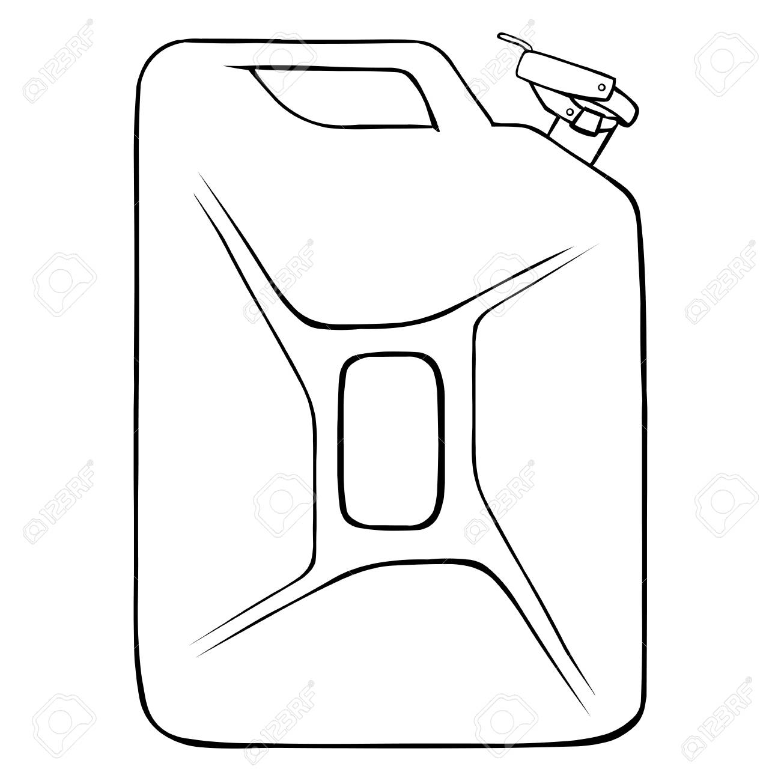
- How many buckets are needed to fill the jerrycan below?
15 litres
300ml

- The perimeter of a square is 24m. Find its area.

- Nakato bought 3 pencils at shs. 700 each and 4 rubbers at shs. 2000. How much money did she remain with if she had a five thousand shilling note?

- Find the volume of a cuboid measuring 9cm by 7cm by 5cm.

- How many 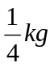of meat can be got from 2kg?

- A dozen of cups cost shs. 72,000. How much money will one pay for 5 cups.

- Use “is greater than”, “is less than” or is “equal to” to complete the statement . 3kg of stones __________________________3kg of feathers.
SECTION B

- Study the figure below.
X + 4m
k-2m
12m
8m

- Find the value of;
- X

- K

- Calculate the area of the above figure.

- Find the perimeter of the above figure in centimeters.

- (a) change 15 litres to milliltres

(b) Add litres ml
6 3 8 0
+ 5 7 6 0

(c) Subtract litres ml
1 2 4 9 0
- 5 5 5 0

- Complete the shopping bill table below.
ITEM | UNIT PRICE | QUANTITY | AMOUNT
Soap | Shs. 3500 | 4 kg | Shs. ____________
Rice | Shs. 7000 | Shs. ____________ | Shs. 21000
Matchbox | Shs. ______________ | 10 packets | Shs. 5000
sugar | Shs. 4000 | Shs. _____________ | Shs.____________
Total expenditure |  |  | Shs.______________

- The perimeter of the rectangle below is 40cm. study it and answer the questions that follow.
P= 40cm
13cm
n

- Find the value of n

- Find its area

- What distance will an insect cover if it moves around the above figure 10 times?

- On a farm of 2400 animals, of them are cattles, are goats and the rest are sheep.
- Find the fraction of sheep

- Find the total number of goats and sheep

- Of the cattles, 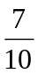are bulls and the rest are cows. Find the number of cows.

- Study the figure below
9m
10m
8m

- Find the perimeter of the above figure

- Find the area of the above figure

GREENHILL PRIMARY SCHOOL BUWAATE
P.5 MATHEMATICS REVISION WORK SET X
TERM III, 2019
Name: ____________________________ Stream: _________

- Add 43 + 22

- Set A ={1, 2 , 3 , 4 , 5} and set B={1, 3, 5, 7, 11} . Find A n B

- How many lines of folding symmetry has a kite?

- If represents 5 cups. How many cups re represented by ?

- The cost of 2 books is shs. 1000. Find the cost of 6 books.

- The length of a bed is 3m. Change this to centimetres.

- If John moves around a rectangular figure of length 10m and width 9m thrice, what distance will he cover?

- The driver covered covered a distance in 3 hours at a speed of 80km/hr. find the distance he covered.

- Find the missing number.
1, 4, 9, 16, ____.

- Collect the like terms and simplify: 9y + 8m – 2y + m

SECTION B
- (a)Complete the abacus below
O
T
H
O
O
O
O
O
O
O
O
O
O
O
O
O
O
T
H
O
O
O
O
O
O
O
O
O
O
T
H
+
=

- Write in figures. Four thousand ninety –six

- Use the venn diagram below to answer the questions that follow.
cat
man
doe
pen
cup
ruler
P
K

- List the elements of set;
- K

- P

- Find n(p-k)

- How many members are in p u k?

- The tank contains 480 litres of water. of the water is used to water the crops and the rest for washing.
- Find the fraction used for washing?

- How many more litres were used for watering crops than washing?

- (a) Add 143_{five} + 101_{five}

- Subtract 13_{five} from 221_{five}

- What is the place value of each digit in 234_{five}

- Write 203_{five} in words.

- (a) Find the GCF of 10 and 8

(b) Fill in the value of the unknown.
24
6
2
1

- Study the numberline below
M
K
⁻5 ⁻4 ⁻3 ⁻2 ⁻1 0 ⁺1 ⁺2 ⁺3 ⁺4 ⁺5 ⁺6 ⁺ 7 ⁺ 8
N

- Find the value of;
(i) K =__________ (ii) N=___________ (iii) M=____________

- Write the mathematical statement shown above.

GREENHILL PRIMARY SCHOOL BUWAATE
P.5 MATHEMATICS REVISION WORK SET XI
TERM III, 2019
Name: ____________________________ Stream: _________

- Convert 2 weeks to days.

- Workout the value of k.
50⁰
2k

- Write the place value of the 6 in 4689.

- Name the set below
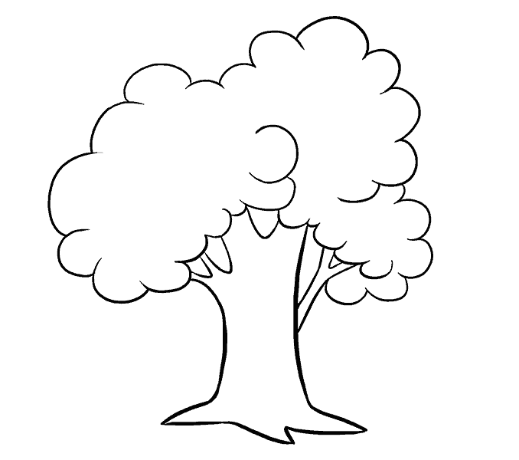

- P.5 pupils can be made to sit in groups of 6 boys or 8 girls leaving no remainder of any child. Find the least number of pupils in P.5.

- Convert 10 as an improper fraction.

- Barbra bought 18 pencils. Draw tallies to show the number of pencils she bought.

- I think of a number, add 8 to it and the result is 29. What is the number?

- Write the expanded number in words. (4 x10) + (9 x 1000) + (3 x 100)

- Osama bought a pen at shs. 10,000 and sold it at shs. 7500. Find his loss.

SECTION B
- (a)With the help of a pencil, a ruler and a pair of compasses only, construct a triangle ABC where AB = 7cm,
BC= AC = 5cm

(b) Find its perimeter

- On the tour day, Rodrick was given the following notes:
3 notes of one thousand shillings
5 notes of five thousand shillings
2 notes of ten thousand shillings.
- How much money was he given?

- If he used shs. 35,000 find his change.

- Use the figure below to answer the questions that follow.
8hm
12hm
m
n

- Find the value of m and n
m=____________

n =_____________

- Calculate its area

- What distance will an insect cover if it moves around the above figure twice?

- (a) Ochodi covered a distance of 120km at a speed of 60km/hr. what time did he take?

(b) A bus took 3 hours to travel from Jinja to Kampala a distance of 81km. find its speed.

(c) The driver covered a distance in 3 hours at an average speed of 80km/hr. find the distance covered.

(d) Write the morning time shown on the clock faces below
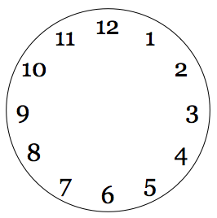

- If m =8, a = 10 and n = 2. Find the value of;
- m + a + n

- ma + 5n

- 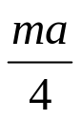

- Use the table below to complete the bar graph below.
Names | John | James | Joseph | Joshua | Joel
Marks | 80 | 90 | 95 | 80 | 100

John
James
Joseph
Joshua
Joel
Marks scored by pupils
Names of pupils
0
10
20
30
40
50
60
70
80
90
100

- Find the range of marks

- What was the modal score?

- Calculate the average mark

GREENHILL PRIMARY SCHOOL BUWAATE
P.5 MATHEMATICS REVISION WORK SET XI
TERM III, 2019
Name: ____________________________ Stream: _________
- Write 23 in words.
- Draw a set of 4 cups
- Find the sum of 45kg and 768kg
- Find the sum of the missing numbers in the sequence: 45, 42, 39, 36, _______,_________
- Bosco was given 7 books by his father and 6 books by his mother. Draw tallies to represent his total number of books.
- Musa bought four and ahalf kilograms of Meat. How many grams did he buy?
- What is the additive inverse of ⁻12?
- Find the fourth equivalent fraction of
- Tom bought 10 tomatoes at shs 2500 and later sold each tomato at shs. 200. What loss did he make?
- What is the larger angle between East and South West?
SECTION B
- Workout the following.
- 214 x 3

- 56421 – 32196

- Share 459 books equally among 3 classes

- Given that set K={a, b, u, s, e} and L={all vowel letters}
- Represent the above information on the venn diagram below
L
K

- Find K u L

- Find n( L- K)

GREENHILL PRIMARY SCHOOL BUWAATE
P.5 MATHEMATICS REVISION WORK EVALUATION TEST 4
TERM III, 2019
Name: _______________________________ Stream: _________

- Our teacher had a maternity leave of five days. For how many hours was her leave?

- Solve for m:

- Dan and Musa carried 6kg of meat each from the butchery. Find the total mass they carried altogether in grams.

- Subtract: 13_{five} from 221_{five}

- Study and complete the abacus below.
O
O
O
O
O
O
O
O
O
O
O
O
O
O

- Use the numberline below to work out 3 x

- Starting from -3, show +5 on the numberline below.

- Show a quarter to five on the clock face below.

- Jovia poured 10 cups of 300ml each into a bucket to fill it. Find the capacity of the bucket.

- Find the square root of 36.

SECTION B
- (a) How many days are in the month of February of a leap year?

(b) A vehicle covered a distance of 120km in 2 hours. At what speed was it travelling?

(c) If the same vehicle is to cover the same distance above at a speed of 40km/hr, what time will it take?

- Oluka bought the following items from the shop.
2 rulers at shs. 3000
4 books at shs. 1200 each
3 pens at shs. 500 each.
- How much money did he spend on all the items?

- If he was given change of shs. 700. How much did he have at first?

- Kasimagwa is p years old and his brother Dodo is ( P+8) years old. If there total age is 30 years old.
- Find the value of p

- How old is Dodo?

- How old will Kasimagwa be 10 years from now?

- Study the map below and answer the questions that follow.
A
10Km
B
C
7Km
5Km

- Find the longest distance from town A to town C

- A rally car was driven around the three towns five times. What distance did it cover?

- Lynette took a direct route from A to town B. her vehicle broke down after covering 2400m. find the distance left to cover the journey.

- The graph below shows the the number of mangoes collected from a farm in five days.
0
10
20
30
40
50
Mon
Tue
Wed
Thur
Fri
Number of mangoes
Days of the week

From the graph above,

- On which day was the least number of mangoes collected?

- Find the range of the mangoes collected

- Find the median number of mangoes

- Find the modal number of mangoes

- Find the average number of mangoes collected.

- Study the numberline below
X
⁻5 ⁻4 ⁻3 ⁻2 ⁻1 0 ⁺1 ⁺2 ⁺3 ⁺4 ⁺5 ⁺6 ⁺ 7 ⁺ 8
P
Y

- Find the value of;

- X =____________

- Y =_________

- P=______________

- Write the mathematical statement shown above.

